



Implementation of iterative statements - for loop
LAB MANUAL

Disclaimer: The content is curated from online/offline resources and used for educational purpose only
Implementation of iterative statements - for loop
Objective:
- To learn how to iterate over each character in a string using a for loop.
- To understand the use of the range() function in a for loop.
- To practice using nested for loops to access elements in a 2D list.
- To understand how the break statement works inside a for loop.
- To understand how the continue statement is used to skip specific iterations.
- To learn how to use the else block with a for loop.
Problem Statement:
- Write a Python program that takes a string (e.g., "Edunet Foundation") and uses a for loop to iterate through each character in the string. The program should print each character individually, displaying one character per line.
- Write a Python program that uses the range() function to generate a sequence of numbers from 0 to 4. The program should utilize a for loop to iterate through this range and print each number on a new line.
- Write a Python program that defines a 2D list (matrix) containing numerical values. The program should use nested for loops to iterate through each row and each element within that row. The elements should be printed in a grid format, with each row appearing on a new line.
- Write a Python program that uses a for loop to iterate through numbers from 0 to 9. The loop should print each number until it reaches the number 5, at which point the loop should terminate using the break statement
- Write a Python program that uses a for loop to iterate through numbers from 0 to 9. The program should print only the odd numbers, skipping all even numbers using the continue statement.
- Write a Python program that uses a for loop to iterate through numbers from 0 to 4. After completing the iterations, the program should print a message indicating that the loop has completed successfully, utilizing the else clause of the loop.

Equipment Required:
- Install VS Code - https://code.visualstudio.com/download
- Download Python Installer File - https://www.python.org/downloads/
Prerequisites:
- Basic Computer Skills - Anyone starting to learn computer programming needs basic computer skills. Python is a cross-platform language, so it makes no difference whether you use a macOS, Windows, or even Linux.

Procedure:
Task 1: Using a for loop to iterate over each character
Task 2: Using range to iterate from 0 to 4
Task 3: Nested for Loop
Task 4: Using break to exit the loop when a condition is met
Task 5: for Loop with continue
Task 6: Using else with a for loop

Task 1: Using a for loop to iterate over each character
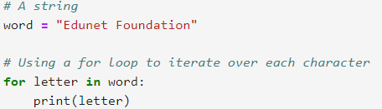
Output:
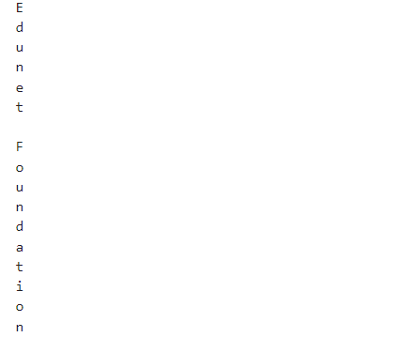
This output shows each character of the string "Edunet Foundation" printed on a separate line. The program effectively demonstrates how to use a for loop to iterate through each character in a string.

Task 2: Using range to iterate from 0 to 4
Output:
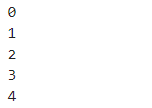
This output shows each number from 0 to 4 printed on separate lines. The program effectively demonstrates how to use the range() function within a for loop to iterate over a sequence of numbers.
Task 3: Nested for Loop
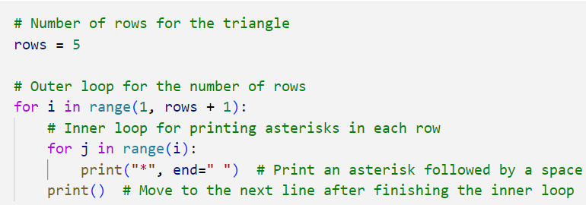
Output:
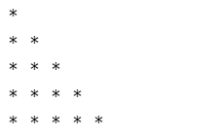
Here, creates a right-angled triangle pattern of asterisks. If you want to change the number of rows, you can modify the rows variable
Task 4: Using break to exit the loop when a condition is met
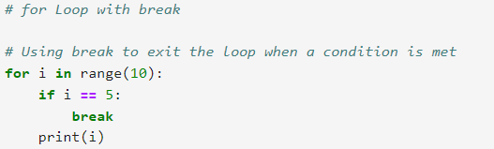
Output:
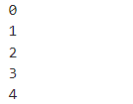
This output displays the numbers 0 through 4, as the loop terminates before printing 5 due to the break statement. The program effectively demonstrates how to control the flow of a loop using the break statement in Python.
Task 5: for Loop with continue
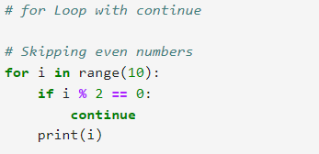
Output:
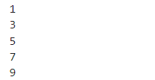
This output displays the odd numbers from 0 to 9, as all even numbers have been skipped due to the continue statement. The program effectively demonstrates how to control the flow of a loop using the continue statement in Python.
Task 6: Using else with a for loop
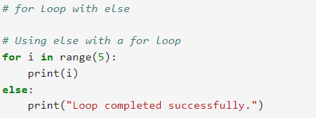
Output:
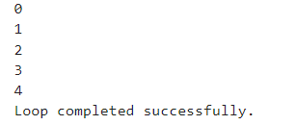
This output shows the numbers from 0 to 4 printed on separate lines, followed by the message confirming that the loop has completed successfully. The program effectively demonstrates how to use the else clause with a for loop in Python.

